



**Mini Project Report**

On

**University Website**

Subject :- DBMS

*Presented By-*

|  |  |  |
| --- | --- | --- |
| Roll No | Batch | Name |
| 230612033217 | *G1* | *HARSHIT JAIN* |
| 230612033238 | *G2* | *NEHA DILODH* |

*Under the guidance of :-*

**Prof. Bushra Jamal**

Signature of Internal Examiner Signature of External Examiner

**CANDIDATE DECLARATION**

Project title: _____**AcademiX** ______

We, **HARSHIT JAIN** and **NEHA DILODH**, certify that this project is our own work, based on our personal study and/or research and that we have acknowledged all material and sources used in its preparation, whether they be books, articles, reports, lecture notes, and any other kind of document, electronic or personal communication. We also certify that this project has not previously been submitted for assessment in any academic capacity, and that We have not copied in part or whole or otherwise plagiarised the work of other persons. We confirm that we have identified and declared all possible conflicts that we may have.

Signed and submitted -

**Candidate ID:** Harshit Jain (230612033217)

and

Neha Dilodh (230612033238)

**Date:** 20 – Nov – 2024

**CERTIFICATE**

This is to certify that the project titled **“AcademiX”** has been successfully completed by **Harshit and Neha** a student of Bachelor of Computer Applications(BCA), Semester 3, during the academic session 2024 - 25.

The project was carried out under the guidance of **Bushra Jamal Mam** and has been submitted in partial fulfilment of the requirements for the degree of Bachelor of Computer Applications at Delhi Skill and Entrepreneurship University.

The project has been thoroughly reviewed and approved, and the student has demonstrated a good understanding of the subject matter.

We wish them success in their future endeavours.

**Signature _____________________**

**( Mrs. Bushra Jamal )**

**Date:** 20 Nov 2024

**Place:** Delhi

**ACKNOWLEDGEMENT**

I am deeply grateful to everyone who has supported and guided me throughout the completion of this project, titled **“AcademiX”**

First and foremost, I extend my heartfelt gratitude to **Mrs. Bushra Jamal**, my DBMS subject teacher, for providing me with this project opportunity and for her invaluable guidance, constructive feedback, and constant encouragement during the project’s execution. Her expertise and patience were instrumental in helping me successfully complete this work.

I acknowledge the resources provided by **Delhi Skill and Entrepreneurship University**, including access to necessary software, tools, and infrastructure, which played a vital role in the project’s success.

Lastly, I would like to thank my family and friends for their encouragement and understanding throughout this journey. Their support has been a source of motivation and strength.

Thank you all for making this project a rewarding and fulfilling experience.

**Harshit Jain (230612033217)  
Neha Dilodh (230612033238)**  
**BCA, Semester 3**

**Abstract:**

***AcademiX*** is an innovative and user-friendly web-based platform designed to streamline and simplify the management of academic processes in a university setting. The system aims to facilitate smooth interaction between students, teachers, and administrators through an intuitive interface, ensuring efficient management of academic and administrative tasks. By integrating a database-driven backend, the platform ensures secure storage and real-time management of data related to courses, schedules, students, faculty, and academic performance.

The platform is structured into Four primary panels: **Website, Student Panel**, **Teacher Panel**, and **Admin Panel**. Each panel offers distinct features tailored to the respective roles. Students can access their personal academic information, view course materials, track attendance, and monitor progress. Teachers can manage their classes, update grades, and communicate with students, while administrators have full control over the system, with the ability to manage users, courses, and data integrity.

The system leverages **MySQL** for database management, ensuring that all information is securely stored and easily accessible. It provides a user-centric experience with easy navigation, ensuring that all stakeholders—whether students, teachers, or administrators—can access the necessary tools and resources without complication.

The objective of *AcademiX* is to improve the efficiency and transparency of university operations by reducing paperwork and manual interventions, ultimately contributing to a more organized and effective academic environment.

Contents

Introduction 8

I. About AcademiX 8

II. Technologies Used 8

III. About the DBMS 9

Purpose/Scope/Objective 10

The Vision Behind AcademiX 10

Real-World Impact and Relevance 10

Requirements for the Project 12

I. Hardware Used 12

II. Software Used 12

III. Technology Used 13

IV. DBMS in Use 14

Methodology 15

Future Scope 35

1. Adding New Features: 35

2. Scaling the Database: 36

3. Improving the UI and Optimizing Performance: 36

Conclusion 38

Bibliography 40

# Introduction

I. About AcademiX

Welcome to **AcademiX**, the next-gen student portal designed to bring the academic experience into the digital age. AcademiX solves the common challenges faced by educational institutions—whether it's tracking student performance, managing faculty details, or streamlining communication. This intuitive platform empowers both students and faculty with a comprehensive suite of features like personalized dashboards, easy access to academic results, and a powerful enquiry system. With its sleek design and powerful backend, AcademiX transforms complex academic management tasks into a smooth and seamless experience, allowing institutions to focus on what truly matters: education.

## II. Technologies Used

AcademiX is built using a modern tech stack that prioritizes both functionality and user experience. The **frontend** is crafted with the versatility of **HTML, CSS**, and **JavaScript** to provide a fast, responsive, and visually appealing interface. These tools ensure that navigating through the platform is not only easy but enjoyable across all devices. The **backend**, powered by **PHP**, acts as the backbone of AcademiX, providing smooth server-side operations that handle everything from user login to data management. But the true powerhouse behind the system is **MySQL**, which securely stores and organizes all the critical data, including student and faculty details, login credentials, and enquiries. MySQL ensures that the platform runs efficiently, even when handling large datasets. The seamless integration between these technologies offers a perfect balance of speed, security, and simplicity.

III. About the DBMS

At the heart of AcademiX’s data management lies **MySQL**, a robust and reliable database system chosen for its efficiency and scalability. With MySQL, we manage everything from secure user authentication in the **login table** to tracking and responding to student queries via the **enquiry table**. It also keeps all the student and faculty data organized and easy to access. The beauty of MySQL lies in its ability to handle complex queries quickly, ensuring users can access their data in real-time. With seamless interaction between the database and the backend, AcademiX delivers an optimized experience—where data is not just stored but managed in a way that makes sense, ensuring users always have what they need at their fingertips.

# Purpose/Scope/Objective

The Vision Behind AcademiX  
  
At its core, **AcademiX** is more than just an academic management platform—it's a game-changer for educational institutions. The goal of AcademiX is to provide a seamless, integrated solution that transforms how students and faculty interact, collaborate, and manage academic data. Built with the latest technologies, the platform connects the dots between students' academic journeys and the institution’s administrative processes, creating a smooth flow of information. By harnessing the power of **MySQL** for robust database management and combining it with an intuitive, easy-to-navigate web interface, AcademiX is the future of academic management—right here, right now.

Real-World Impact and Relevance  
  
In a world where education is evolving faster than ever, AcademiX stands as a solution that adapts to both student and faculty needs in a modern, digital-first environment. Students gain real-time insights into their performance, access key academic data in seconds, and receive instant feedback through an **enquiry system**—making the entire learning process more transparent and accessible. Faculty members can effortlessly manage student information, track progress, and communicate with students—all from a centralized dashboard. This dynamic, user-friendly interface ensures that **AcademiX** is not just another system, but an essential tool that empowers users to take charge of their academic experience. The combination of **student dashboards**, **faculty management**, and **data-driven decision-making** ensures that this platform isn't just a tool—it's a productivity powerhouse for educational institutions.

**The scope for Development**  
  
While AcademiX already sets the stage for a streamlined, efficient academic ecosystem, the possibilities for growth are limitless. Future developments could introduce **online grading systems**, **advanced student performance analytics**, and **attendance tracking**—enhancing how students and faculty interact with academic data. The addition of **payment integration** and tools for **course management** would broaden the platform’s capabilities even further, making AcademiX an all-in-one hub for educational institutions. And with the rise of mobile-first platforms, **AcademiX** could evolve into a fully mobile-friendly solution, giving users on-the-go access to everything they need, whenever they need it. The future is bright, and **AcademiX** is just getting started—transforming not just how schools run, but how education is experienced.

# Requirements for the Project

## I. Hardware Used

To power AcademiX and ensure a smooth, efficient development process, we used a system built for performance and reliability. The hardware setup includes:

* **Processor**: Intel Core i3-1005G1 CPU @ 1.20GHz, providing the necessary processing power to run the application, handle backend operations, and execute front-end functionalities efficiently.
* **RAM**: 4 GB, which was sufficient for the development environment, running multiple applications and the local server without major slowdowns.
* **Storage**: Ample disk space to store project files, databases, and backups, ensuring we had enough room to manage the project as it evolved.

This hardware configuration allowed us to seamlessly run the development tools, manage database queries, and build AcademiX without encountering any system limitations.

## II. Software Used

AcademiX was built using a powerful suite of tools designed for efficient and rapid development. The key software used includes:

* **Visual Studio Code (VS Code)**: The primary editor for writing clean, efficient code. VS Code’s flexibility with extensions for HTML, CSS, JavaScript, and PHP helped speed up development, making coding smoother and debugging easier.
* **XAMPP**: A local server environment running Apache, PHP, and MySQL. XAMPP provided the backend infrastructure required to run AcademiX in a real-world environment without relying on external hosting. It also enabled us to use phpMyAdmin for managing MySQL databases.
* **Google Chrome**: The primary browser for testing and debugging the platform. Chrome's developer tools helped us analyze performance, check for errors, and ensure cross-browser compatibility.
* **GitHub**: GitHub was crucial for collaboration and version control. It allowed our team to share project files, manage different versions of the codebase, and maintain a seamless workflow during the development process. This also helped in tracking changes, managing contributions from teammates, and ensuring smooth integration of new features.

Together, these tools formed the backbone of the development environment, ensuring a polished final product and efficient collaboration.

## III. Technology Used

AcademiX was developed using a blend of modern web technologies, ensuring a dynamic, responsive, and powerful user experience. These technologies include:

* **HTML**: The skeleton of the platform. HTML structured the content of each page and provided the basic layout, ensuring a clean and accessible user interface.
* **CSS**: Through elegant and responsive design, CSS brought visual appeal to the platform. With custom styles and responsive grids, the design adapts seamlessly to various screen sizes, ensuring a polished look on both desktop and mobile devices.
* **JavaScript**: Powered the dynamic interactions on the platform. From form validation to interactive content updates, JavaScript ensured smooth, real-time user interactions without needing to reload the page.
* **PHP**: The backbone of the server-side logic. PHP handled user authentication, form submissions, and the integration of dynamic features like login, student dashboards, and faculty management.

These technologies combined to form a full-stack solution that allowed for both a compelling user interface and seamless server-side functionality.

## IV. DBMS in Use

The AcademiX platform relies on MySQL, integrated seamlessly through phpMyAdmin on a local server environment via XAMPP. Here’s why MySQL was the perfect choice for the project:

* **Scalability**: MySQL's ability to efficiently manage large amounts of data was essential for handling growing student and faculty data over time. As the project scales, MySQL will continue to support efficient database management.
* **Reliability**: Using MySQL ensures the stability of critical data such as student and faculty records, login information, and inquiries. Its built-in data integrity features ensure that information remains secure and reliable.
* **Ease of Integration**: MySQL was integrated with the backend through phpMyAdmin, which enabled easy creation, modification, and management of essential database tables like **login**, **student details**, **faculty details**, and **enquiries**.

This combination of MySQL and phpMyAdmin on a local server setup ensures that AcademiX is reliable, scalable, and ready to handle the demands of a growing academic platform.

# Methodology

The development of AcademiX involved carefully planning the database schema, user flow, and secure login processes. Below is a detailed methodology explaining the step-by-step process of the project, from the structure of the tables to the constraints used to ensure data integrity.

**I. About Your Tables: Describe the Schema and Structure**

The core of AcademiX lies in its database, which is structured to store essential data related to students, faculty, and administrative tasks. The following are the key tables and their structure:

1. **Admin**

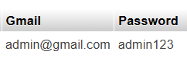

* + **Schema**:
    - **Gmail**: Stores the administrator's Gmail ID for authentication.
    - **Password**: Stores the administrator's password for secure login.

1. **Contact_us**



* + **Schema**:
    - **Name**: Stores the name of the person reaching out.
    - **Email**: The email address of the individual for further communication.
    - **Qualification**: The qualification of the person (e.g., student, parent).
    - **Course**: The course of interest to the individual.
    - **State**: The state the person is from.
    - **Number**: The contact number provided by the person.

1. **Faculty**

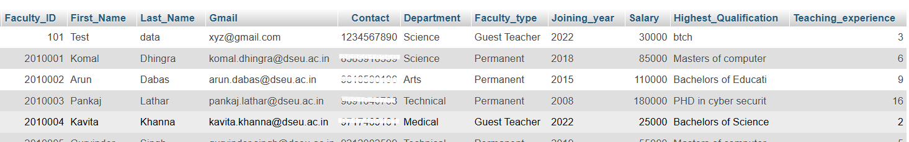

* + **Schema**:
    - **Faculty_ID**: The unique identifier for each faculty member.
    - **First_Name**: The first name of the faculty member.
    - **Last_Name**: The last name of the faculty member.
    - **Gmail**: The Gmail ID of the faculty for communication and login.
    - **Contact**: The faculty's contact number.
    - **Department**: The department to which the faculty belongs.
    - **Faculty_type**: Type of faculty (permanent, visiting).
    - **Joining_year**: The year the faculty joined the university.
    - **Salary**: The faculty's salary details.
    - **Highest_Qualification**: The highest qualification held by the faculty.
    - **Teaching_experience**: The faculty’s years of experience in teaching.

1. **Student**

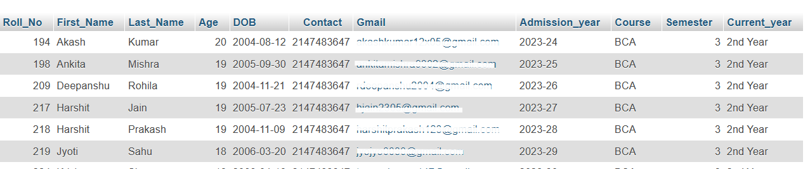

* + **Schema**:
    - **Roll_No**: Unique roll number assigned to each student.
    - **First_Name**: The first name of the student.
    - **Last_Name**: The last name of the student.
    - **Age**: The student's age.
    - **DOB**: The student's date of birth.
    - **Contact**: The student's contact number.
    - **Gmail**: The student's Gmail ID used for communication and login.
    - **Admission_year**: The year the student was admitted.
    - **Course**: The course the student is enrolled in.
    - **Semester**: The current semester the student is in.
    - **Current_year**: The current year of study (e.g., 1st year, 2nd year).

1. **stu_login**



* + **Schema**:
    - **Gmail**: The student's Gmail ID used for authentication.
    - **Password**: The student's password for secure login.

1. **faculty_login**



* + **Schema**:
    - **Gmail**: The faculty's Gmail ID used for authentication.
    - **Password**: The faculty’s password for secure login.

**II. ER Diagram: Representing Relationships**

The **Entity-Relationship (ER) Diagram** illustrates the relationships between different entities in the AcademiX database. The diagram represents how the **stu_login** and **faculty_login** tables link to the **student** and **faculty** tables using the **Gmail** attribute, ensuring that students and faculty can access their respective dashboards upon successful login.

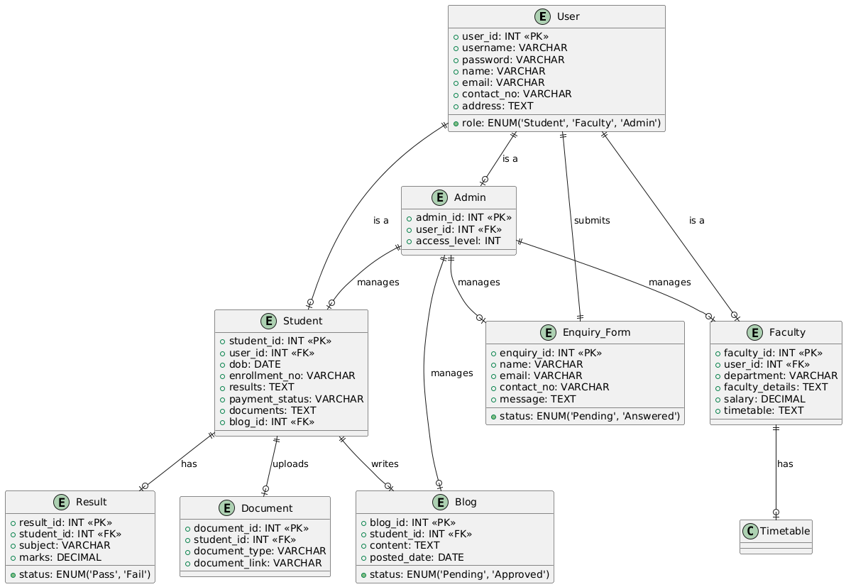

**III. Login Page: Functionality and Security**

The **Login Page** serves as the access point for both students and faculty. Here’s how the login functionality is designed:

* **Student Login**: Validates the Gmail and password entered by the student against the **stu_login** table to grant access to their personalized dashboard.
* **Faculty Login**: Validates the Gmail and password entered by the faculty member against the **faculty_login** table to allow faculty members to manage academic records.
* **Admin Login**: The **Admin Login** page is **not publicly accessible**. Admins must access it through a **direct URL** that is not listed on the website. This keeps administrative functions secure and restricted to authorized users only.
* **Security Measures**: Passwords are stored securely using hashing techniques to prevent unauthorized access. Sessions are created upon login to ensure users stay authenticated throughout their interaction with the platform.

**IV. Constraints: Primary Key, Foreign Key, Super Key, and More**

In order to maintain data integrity, consistency, and optimize performance, various database constraints are applied throughout the schema. Here are the key constraints used in AcademiX:

1. **Primary Key**:  
   The **Primary Key** ensures that each record in a table is unique and can be identified without ambiguity.
   * **Example**:
     + **student** table: The **Roll_No** serves as the primary key to uniquely identify each student.
     + **faculty** table: The **Faculty_ID** is the primary key, ensuring each faculty member’s data is distinct.
2. **Foreign Key**:  
   The **Foreign Key** constraint ensures referential integrity between tables, meaning that a record in one table refers to a valid record in another.
   * **Example**:
     + **student** table: The **Gmail** field is a foreign key that connects to the **stu_login** table, ensuring that only valid Gmail accounts can be used for student login.
     + **faculty** table: Similarly, the **Gmail** field in the **faculty** table acts as a foreign key referencing the **faculty_login** table.
3. **Unique Key**:  
   The **Unique Key** constraint guarantees that all values in a column are different from each other.
   * **Example**:
     + **admin** table: The **Gmail** column is constrained with a unique key to ensure only one admin can use a specific Gmail address.
     + **stu_login** and **faculty_login** tables: The **Gmail** column in both of these tables is unique, ensuring no duplicate email addresses.
4. **Super Key**:  
   A **Super Key** is a set of attributes that uniquely identifies each record in a table. The **Primary Key** is a minimal super key, meaning it contains only the necessary attributes to uniquely identify a record.
   * **Example**:
     + In the **faculty** table, a super key can consist of multiple fields (e.g., **Faculty_ID**, **Gmail**) which can be used to uniquely identify faculty records.
5. **Not Null**:  
   The **Not Null** constraint ensures that a column cannot have a null value. This is essential to make sure that important fields (e.g., **Gmail**, **Password**) contain valid data.
   * **Example**:
     + **stu_login** and **faculty_login** tables: The **Gmail** and **Password** fields are marked as **NOT NULL** to ensure that no empty values are entered for login credentials.

# Where it actually started from?

# The IDEA

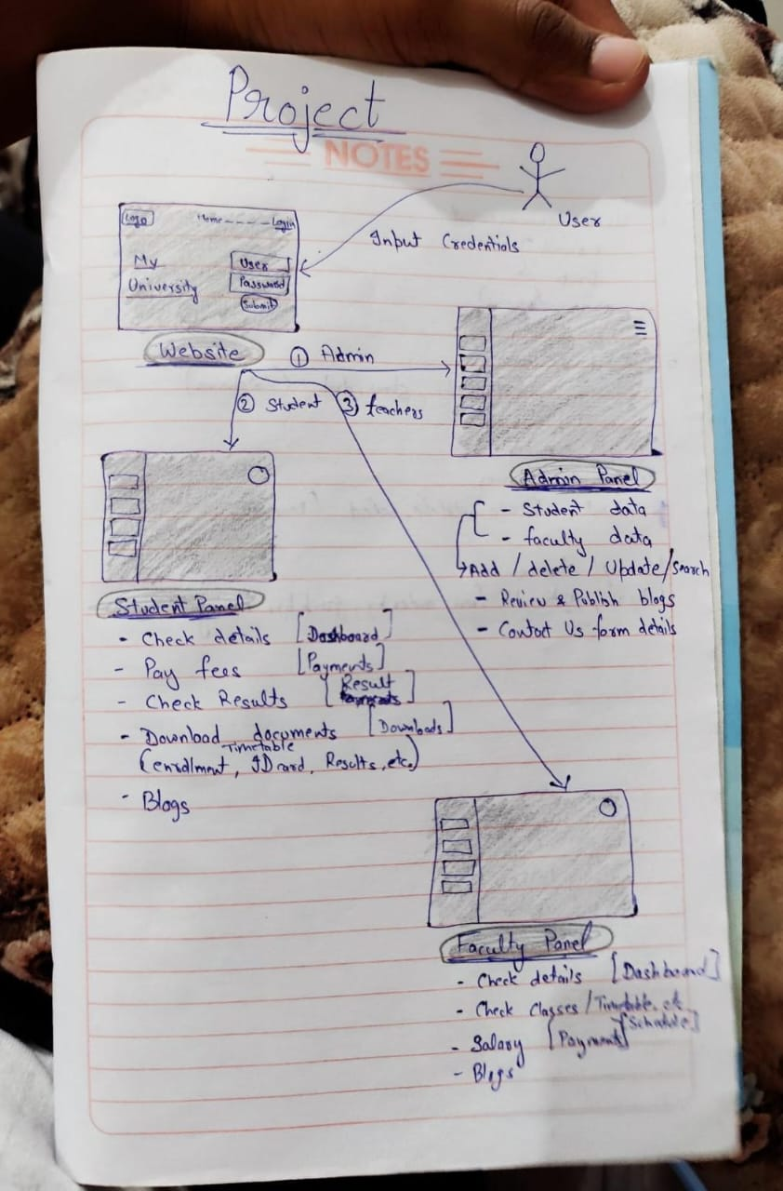

# Screenshots of Website

(Where Project actually goes and how it ended)

***Screenshots of Website***

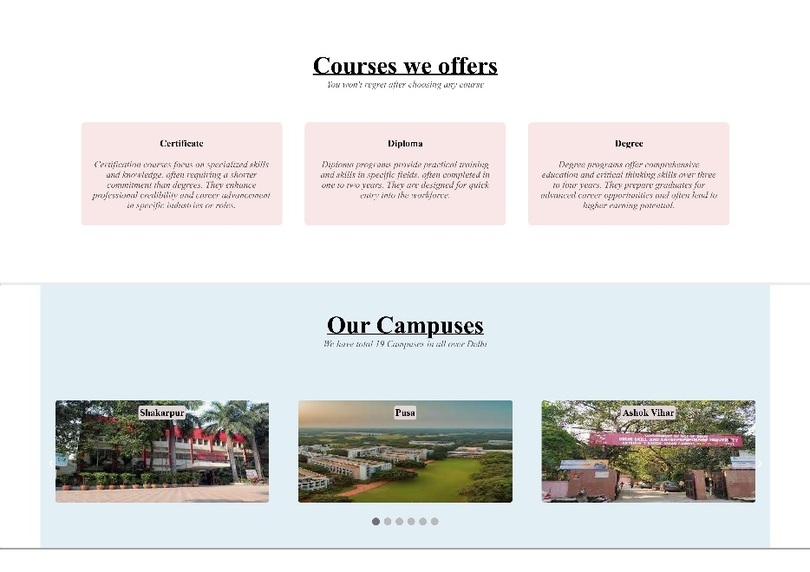

**HOME PAGE**

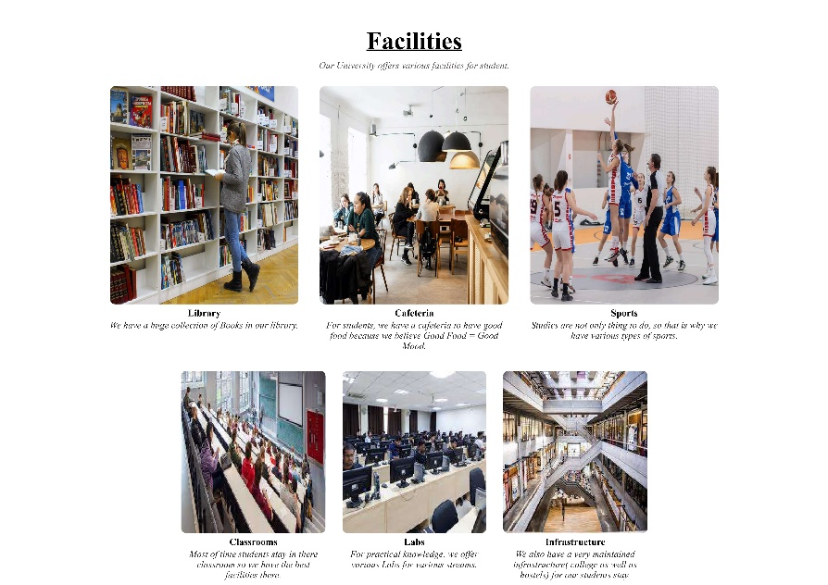

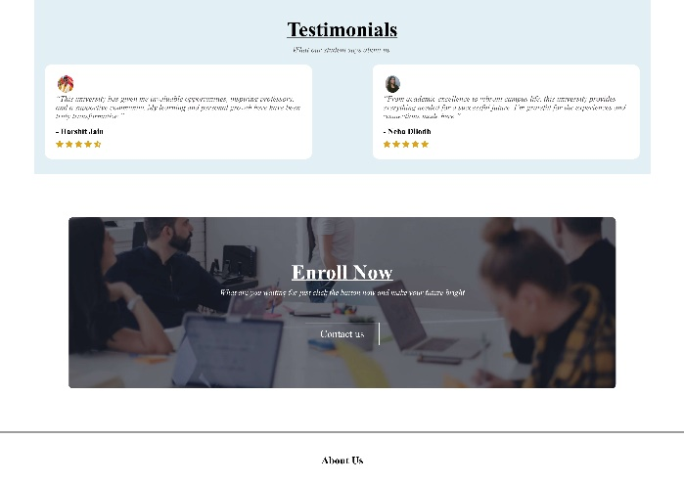

**ABOUT PAGE**



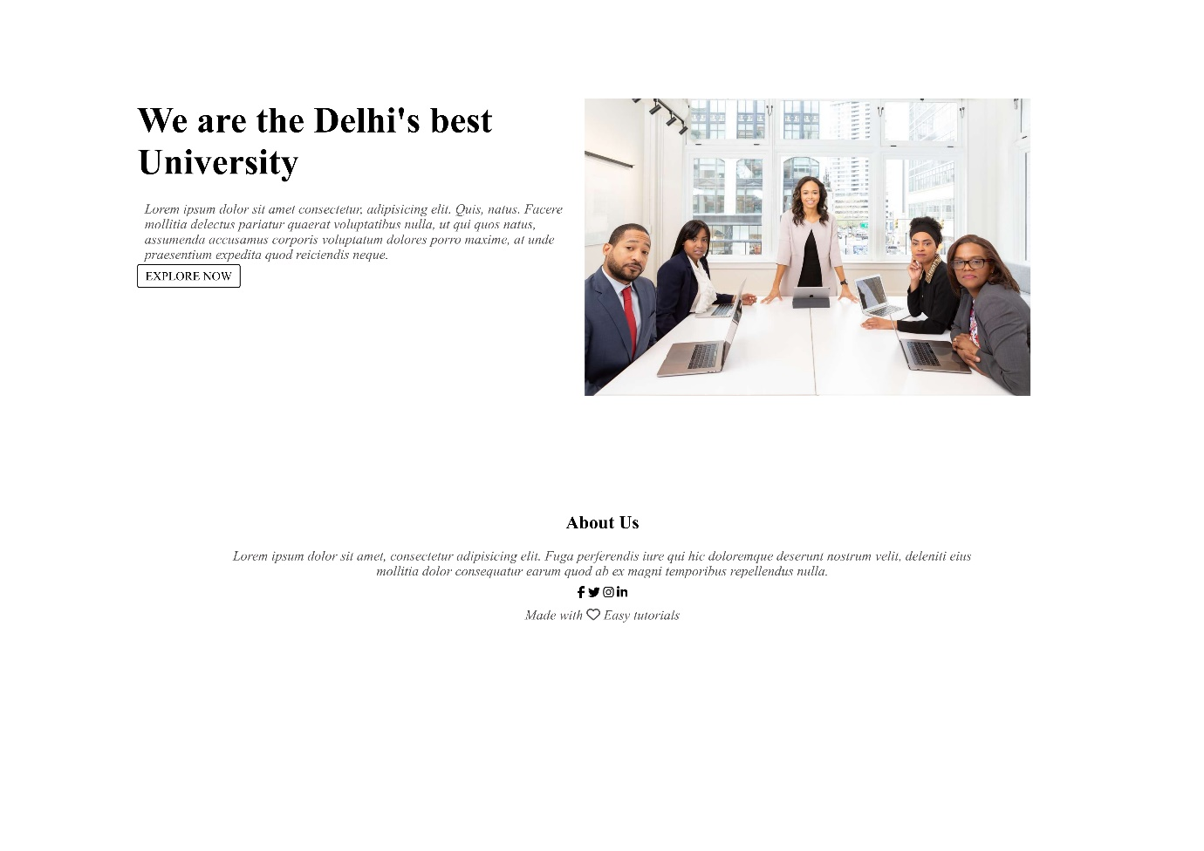

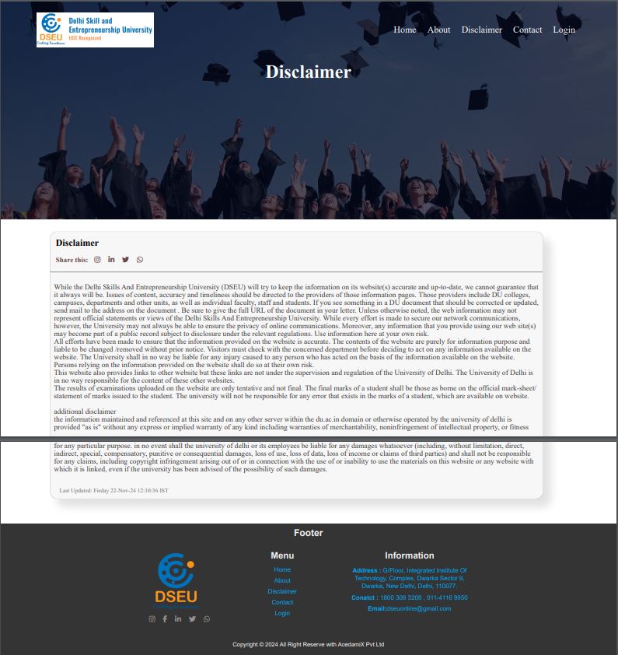

**Disclaimer PAGE**

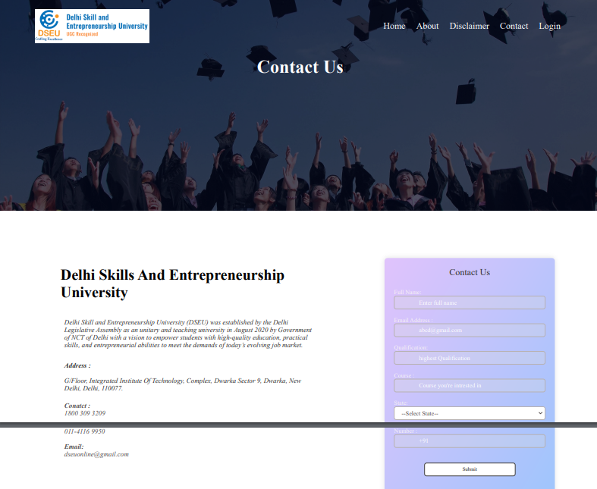

**Contact PAGE**

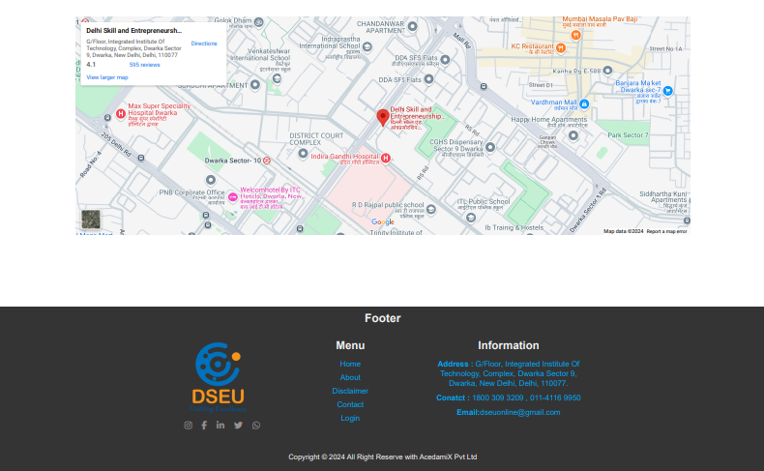

**LOGIN PAGE**

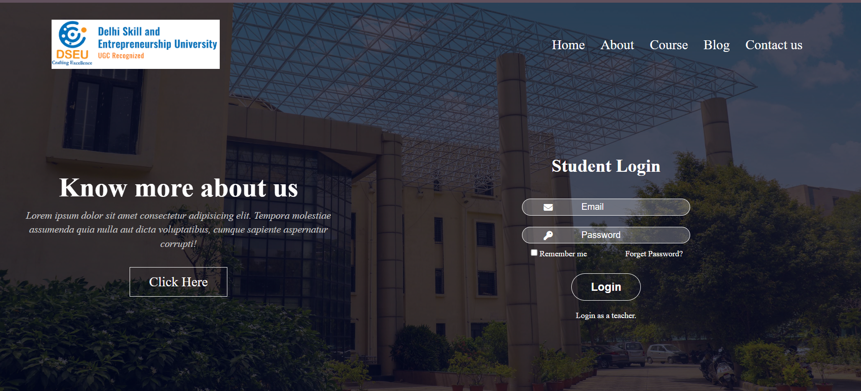

After Login:- **Student-Portal**

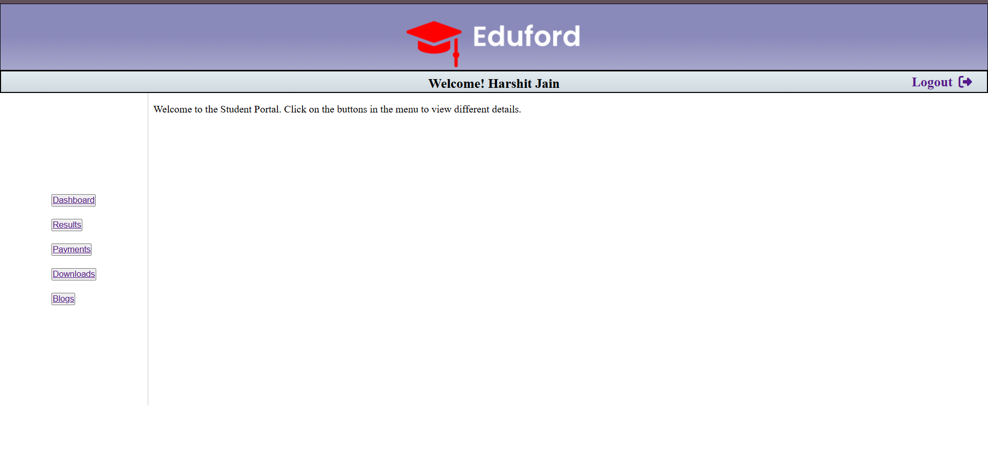

Student Details---

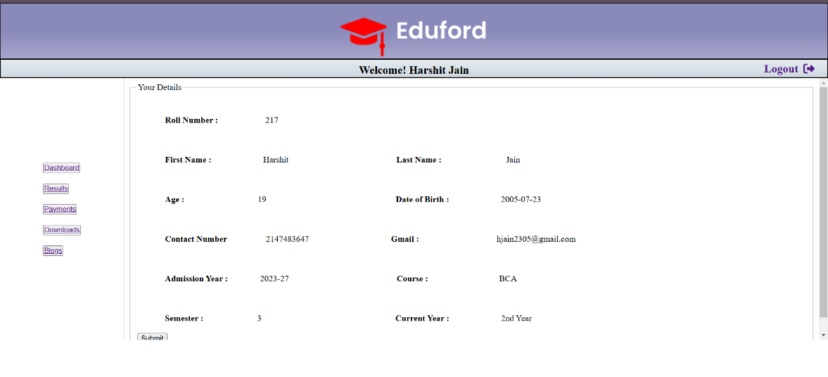

Result page---

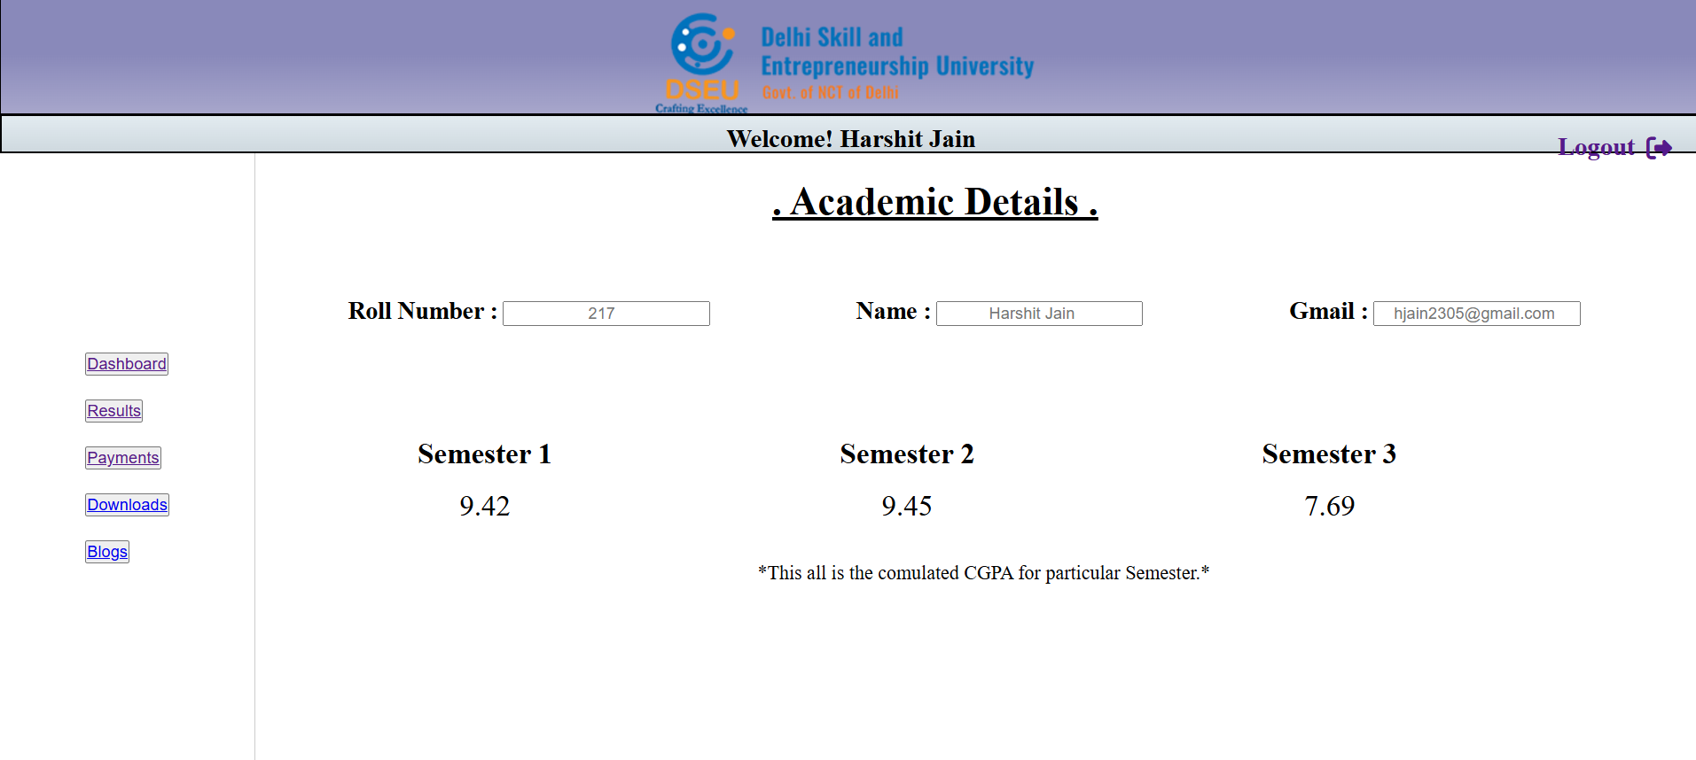

Payment Section ----

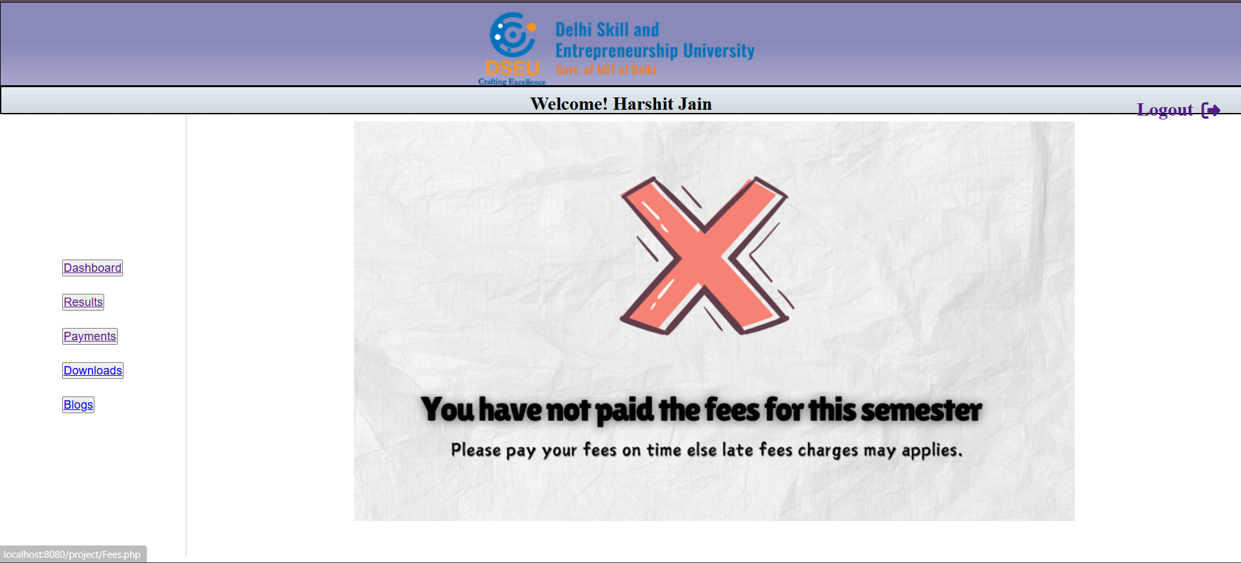



**LOGIN PAGE**

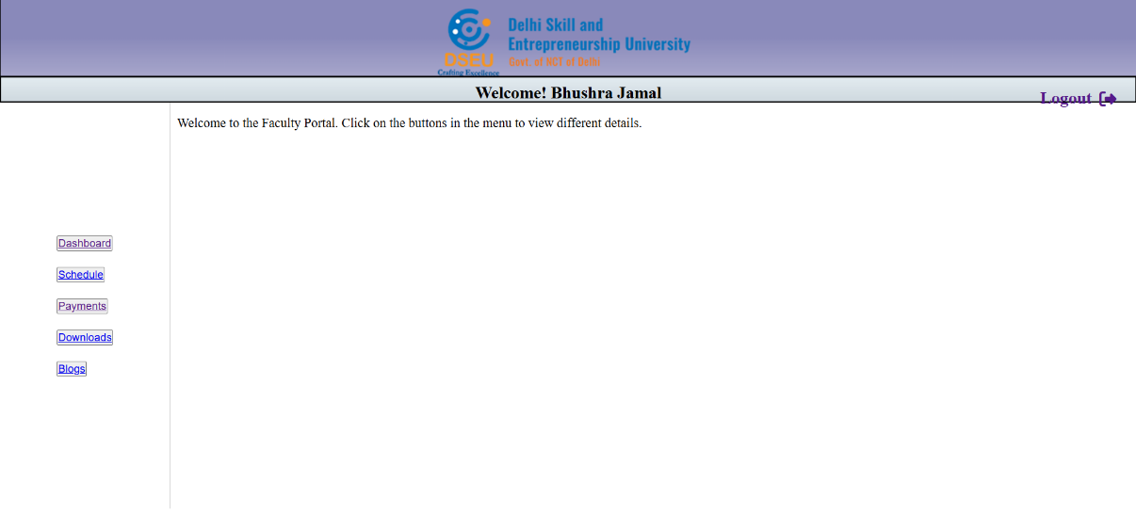After Login:- **Teachers-Portal**

Student Details---

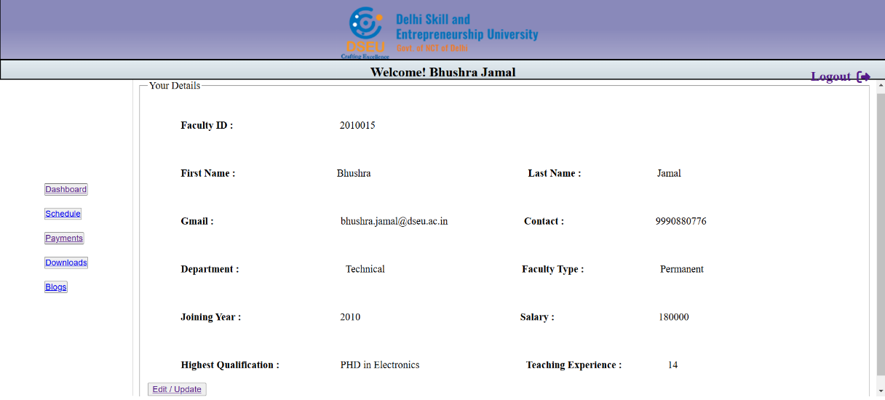

Salary page ---

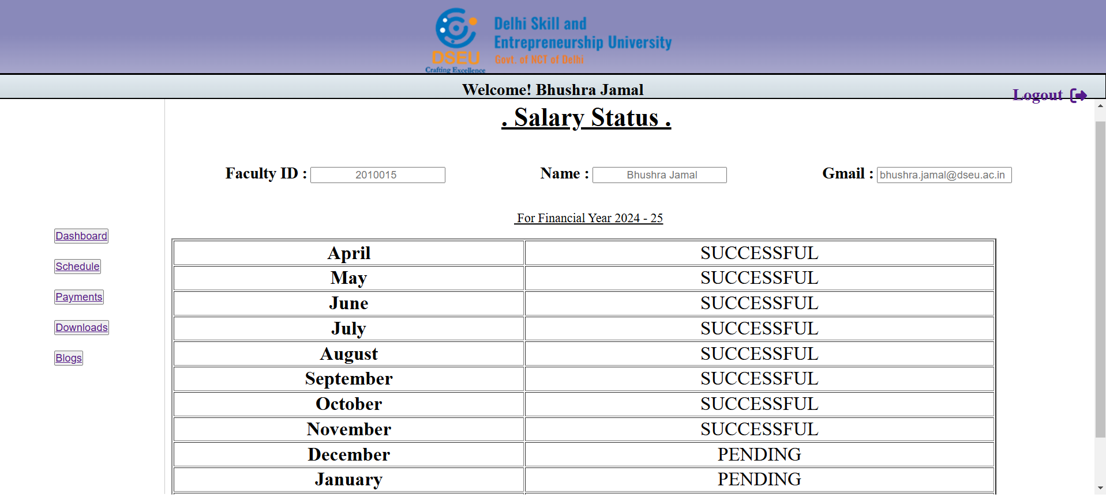

**Admin-LOGIN**

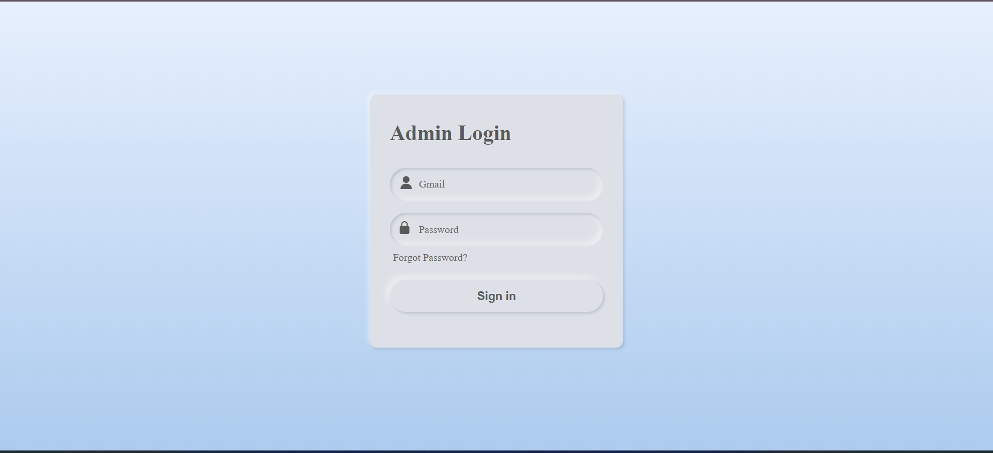

After Login:-

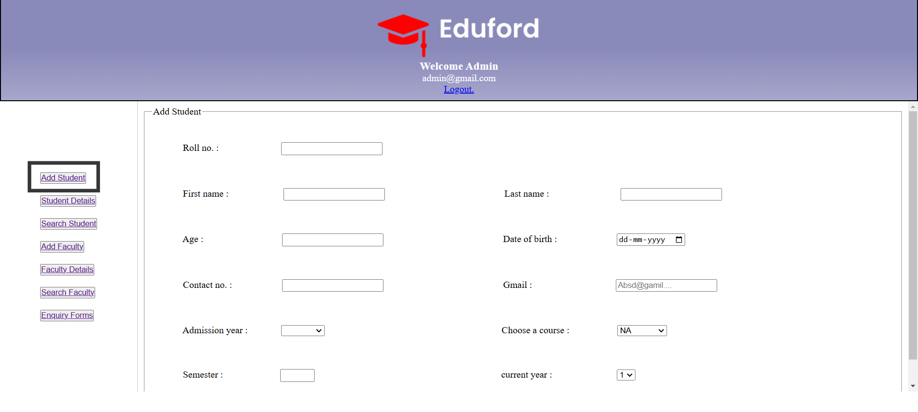

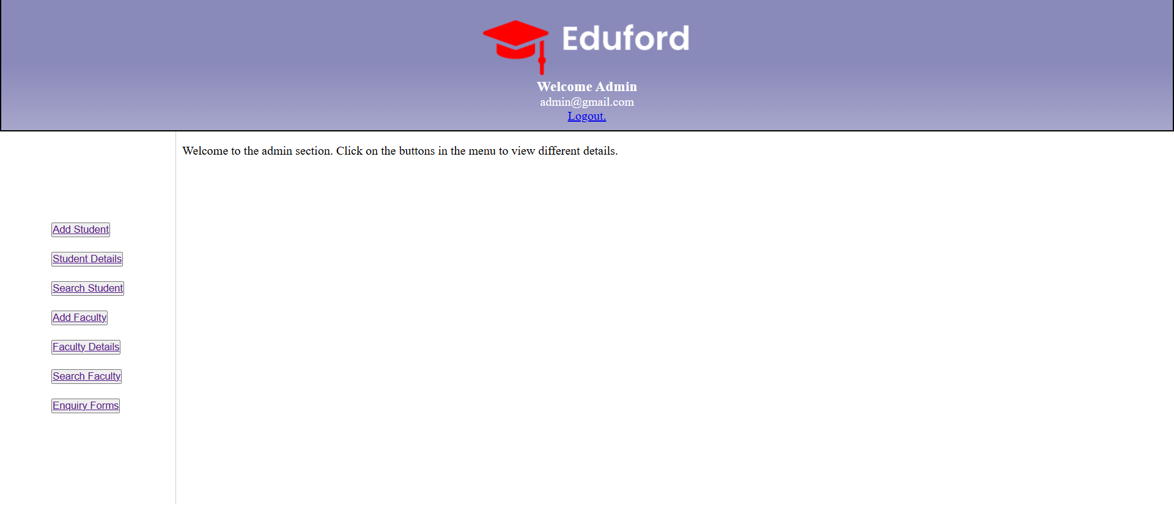

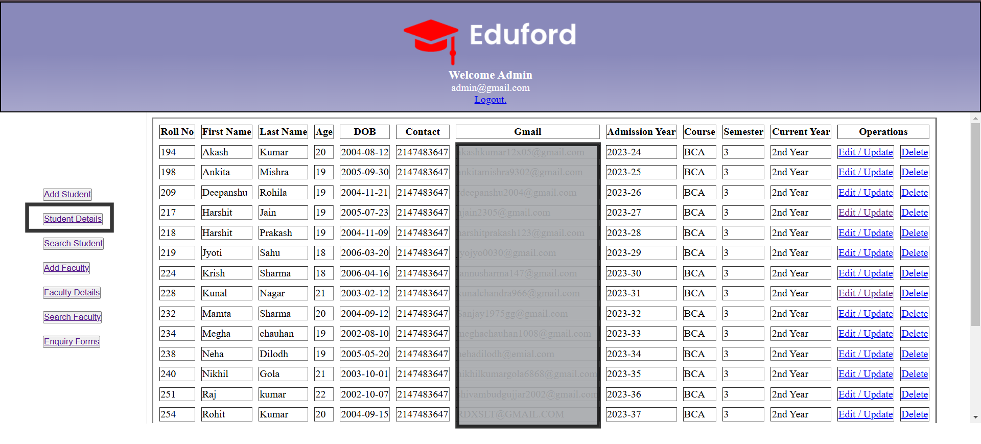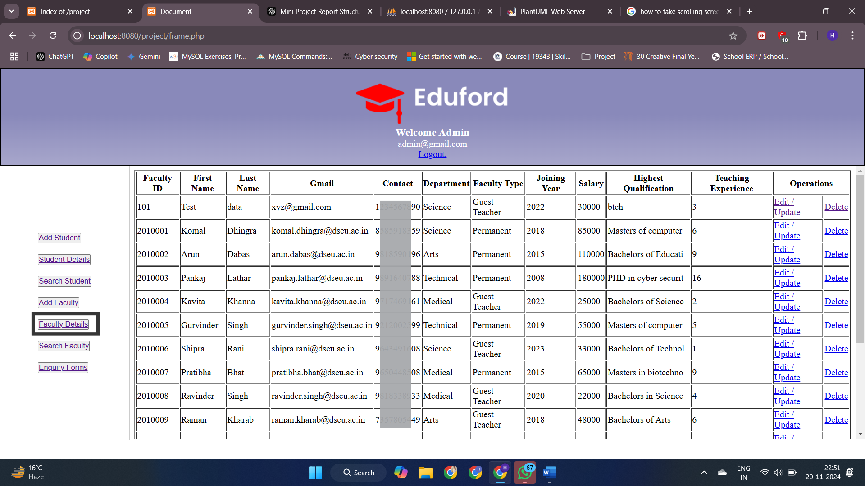Future Scope

The **AcademiX** project is designed with flexibility and scalability in mind, paving the way for future enhancements that will elevate the platform's functionality, user experience, and performance. Here are some potential areas for improvement:

## 1. Adding New Features:

* **Advanced Analytics and Reporting:** Introducing analytics dashboards for both students and faculty to track academic progress, performance metrics, and faculty teaching effectiveness.
* **Discussion Forums and Communication Tools:** Adding a forum for students and faculty to interact, share resources, and collaborate. This feature could include messaging systems or group chats.
* **Online Exam Integration**: Incorporating features for students to take online exams, view results, and even receive feedback from faculty.
* **Multi-language Support:** Expanding the platform's accessibility by integrating multiple languages, making it available to a larger audience across different regions.
* **File Sharing and Collaboration Tools**: Enabling students and faculty to upload and share study materials, assignments, and resources seamlessly within their respective portals.

## 2. Scaling the Database:

* **Handling Larger Data Volumes**: As the number of users increases, the database will need to scale efficiently. Implementing partitioning or sharding to distribute data across multiple servers would ensure quick access and better performance.
* **Cloud Integration:** Migrating the database to cloud-based services such as AWS or Google Cloud for enhanced scalability and to support future growth.
* **Optimizing Queries:** As the database grows, optimizing SQL queries and database indexing will be crucial to maintain fast access to data and improve overall system performance.

## 3. Improving the UI and Optimizing Performance:

* **Responsive Design Enhancements**: While the current design adapts to mobile screens, future updates could further optimize the user interface for various devices, ensuring a more fluid experience across tablets, smartphones, and desktops.
* **User Experience (UX) Improvements:** Implementing a more intuitive and visually appealing UI with improved navigation, smoother transitions, and interactive elements will make the platform even more user-friendly.
* **Performance Optimization:** Leveraging caching techniques, minimizing HTTP requests, and compressing images and files will significantly improve page load times and overall performance. Additionally, implementing lazy loading for large content can help reduce the initial load time of pages.
* **Enhanced Security:** Improving security features by adding two-factor authentication (2FA), encrypting sensitive data, and adopting best practices for secure data transmission can further safeguard user data.

These enhancements, combined with the current features of AcademiX, will not only improve user experience but also ensure that the platform remains adaptable to the evolving needs of educational institutions.

# Conclusion

The **AcademiX** project has been an enriching journey that allowed me to integrate my technical skills while addressing real-world problems faced by educational institutions. Through the development of this platform, I’ve gained valuable experience in various aspects of **web development**, **database management**, and **project design**.

**What I Learned:**

* **Full-Stack Development**: Building a dynamic web application using **HTML**, **CSS**, **JavaScript**, and **PHP** has sharpened my ability to work across the entire development stack, from designing the front-end to implementing back-end functionality.
* **Database Design and Management**: Working with **MySQL** has deepened my understanding of relational database systems, query optimization, and data management. It was fascinating to design and integrate multiple tables, ensuring smooth interaction between users and the system.
* **Security Measures**: Implementing login systems and user-specific roles taught me the importance of securing data and protecting user privacy, which is crucial for any real-world application.
* **Collaboration and Version Control**: Using **GitHub** for version control and team collaboration taught me how to manage code changes efficiently, especially when working in teams.

**Challenges Faced:**

* **Database Integration**: One of the major challenges was ensuring seamless communication between the front-end and back-end, particularly when handling complex queries and large data sets.
* **Designing for User Experience**: Creating a user-friendly interface that worked efficiently across devices was challenging but rewarding. Striking the right balance between functionality and aesthetics required continuous testing and iteration.
* **Security Implementation**: Ensuring that sensitive data, especially in the login system, was securely stored and transmitted required careful planning and research to avoid common vulnerabilities.

**The Significance of the Project:**

**AcademiX** is more than just a learning exercise; it serves as a practical solution to the inefficiencies in university management systems. By automating and centralizing crucial functions such as student enrollment, faculty management, and real-time updates, the platform offers a seamless and efficient experience for both students and faculty members.

Moreover, the project has set a foundation for future scalability and additional features, making it adaptable to a wide range of educational institutions. Its success proves that with the right blend of technologies, a robust, dynamic, and secure platform can be developed to meet the growing demands of modern education systems.

In conclusion, **AcademiX** has been a fulfilling project that not only honed my technical skills but also provided valuable insights into real-world application development and the importance of thoughtful design in solving complex problems.

# Bibliography

Below are the resources that were referenced during the development of the **AcademiX** project:

1. **Tools and Platforms Used:**
   * **ChatGPT**  
     Used as an AI assistant for generating code snippets, solving programming challenges, and helping with general queries related to the project.
2. **Web Design and Development Resources:**
   * **Font Awesome** (<https://fontawesome.com/>)  
     Utilized for high-quality icons to enhance the visual appeal and functionality of the user interface.
   * **Google Fonts** (<https://fonts.google.com/>)  
     Used the **EB Garamond** font to ensure a clean and readable text layout for the website.
3. **Youtube Channels**
   * **Codehal** (Codehal)  
     Used tutorials and templates for creating the **login** and **signup** pages, which were essential components of the project’s authentication system.
   * **Cyber Warriors** (Cyber Warriors)  
     Provided guidance and resources for **PHP integration** and **database management**, allowing smooth communication between the front-end and back-end systems.
   * **GreatStack** (GreatStack)  
     Offered templates and tutorials that helped in designing the **front-end** layout and creating a user-friendly interface for the AcademiX platform.
4. **Additional Web Resources:**
   * **Uiverse** (<https://uiverse.io/>)  
     A resource for **pre-built UI components**, including buttons and forms, which were integrated into the project for a polished look and feel.
   * **Web Gradients** (<https://webgradients.com/>)  
     Used for selecting and applying **CSS gradient colors**, enhancing the aesthetic appeal of the website’s background and elements.
5. **Version Control and Collaboration:**
   * **GitHub** (github.com)  
     Used for **version control**, managing the project files, and collaborating with my partner for real-time updates and project management.
6. **Frameworks and Development Tools:**
   * **XAMPP**  
     XAMPP was used to set up a local server environment with **Apache**, **PHP**, and **MySQL**, enabling seamless back-end development and testing.
   * **VS Code** (Visual Studio Code)  
     The primary code editor used for writing and editing all project files, with support for extensions that enhanced coding efficiency and productivity.

These resources played a key role in the development of **AcademiX**, from coding to design to collaboration, ensuring a smooth and efficient process throughout.

**Thanking You**